Beyond Disposables: Eco-Clamshell Reusable To-go Program
Alison Ormsby, Associate Professor of Environmental Studies
Sponsoring Professor
Eckerd College, 4200 54th Avenue S., St. Petersburg, FL 33711
727-864-8379, ormsbyaa@eckerd.edu

Audrey Copeland
Grant Research and Development Coordinator
213-500-6320, copelaam@eckerd.edu, 380 Parke Street, Pasadena, CA 91101

KEYWORDS: waste minimization, closed-loop, innovative, sustainability

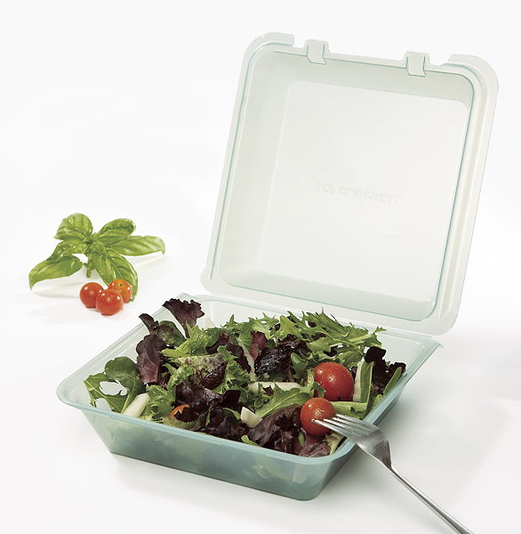

FINAL REPORT

Prepared for the
Environmental Research and Education Foundation
Alexandria, VA

December 2009

Executive summary
The Eco-Clamshell reusable to-go model provides a cost-effective waste management solution. This system not only reduces the total amount of landfill waste generated from disposable containers, but also minimizes the entire environmental impact throughout the life cycle (production, transportation, reuse, and disposal) of the product. Annually this program is estimated to keep 32 million disposable containers out of the landfill.
To date, 160 colleges and universities throughout North America have signed up for the program, along with a number of corporate and healthcare facilities. The use of a reusable to-go model has grown exponentially since the containers launched in April of 2008. As each new account adopts the program, more containers are diverted from landfills.
Waste management and reduction are critical issues in the United States and beyond. The Eco-Clamshell reusable to-go program reduces solid waste using a product that is easy and attractive for consumers.

Table of Contents

Section  Introduction | Page Number  4
Results and Discussion  Prototype Production  Nationwide Dissemination  Summative and Formative Feedback  Marketing the Program  Life Cycle Inventory and Comparative Analysis  Future and Conclusions | 4  4  5  7  8  10
Materials and Methods  Surveys  Life Cycle Analysis | 10  10
Acknowledgements | 11
References | 12
Appendices  Appendix 1: Eco-Takeout Series  Appendix 2: Eco-Clamshell Adoptions Throughout North America  Appendix 3: Eco-Clamshell Student Survey Questionnaire  Appendix 4: Eco-Clamshell Comparative Analysis Survey  Appendix 5: Cost Calculator  Appendix 6: Eco-Clamshell Handbook  Appendix 7: Data and Calculations  Appendix 8: Eco-Clamshell Media Coverage | 13  14  18  19  20  21  37  40

Introduction

Each year millions of disposable to-go containers end up in landfills across the United States. Not only is this harmful to the environment, but the cost of disposing of these containers is tremendous. To resolve both of these issues, Eckerd College, located in Saint Petersburg, Florida, researched and developed a reusable to-go system and container. The following report presents the principal findings of this study and the development of a unique container, called the Eco-Clamshell.

Results and Discussion

Prototype Production
Initially, we searched for a container already existent in the marketplace that would work for the proposed application: To provide students with a cost-effective, reusable alternative to the commonly used disposable Styrofoam take-out container. It became clear that none of the currently available products met the necessary criteria. This led to the construction of a prototype with the following attributes:
- Heat resistant up to 180 degrees Fahrenheit (commercial dishwasher safe)
- Stackable for efficient use of space
- Durable material that can be designed for multi-use applications
- Hinged-lid to minimize the loss of parts
- BPA free plastic, safe for food service (polypropylene)

In the fall of 2007, G.E.T. Enterprises agreed to create the initial prototype for use at Eckerd College. In April of 2008 the first “fleet” of Eco-Clamshells went into circulation at Eckerd College.
At the end of spring semester 2008 we conducted a survey to evaluate the container design and system administration. This formative feedback was used to refine and improve the design. Based on feedback, the hinge was reinforced and a texturized interior was added to the containers to prevent food from slipping. Since that time, G.E.T. Enterprises has continued to improve the design of the containers. Not only have they created additional prototypes, such as a soup container, but they recently redesigned the containers so they are 100% leakproof. Customer feedback has been an important factor for refining and expanding the product offerings. Appendix 1 displays images for the current line of Eco-Takeout™ reusable containers.

Nationwide Dissemination
A major aspect of this project was “nationwide dissemination.” These efforts have been very successful. Appendix 2 displays the universities and other locations that have adopted a reusable to-go program. There are currently 160 colleges and universities throughout the United States and Canada with an established program. Hundreds more have purchased a small quantity and are testing the program. In addition, there are approximately 40 healthcare and corporate locations using the system. One of the most notable companies is Google. They have instituted the program at their headquarters in Mountain View, California. G.E.T. Enterprises expects the number of accounts to quadruple in 2010.
One of the milestones for the spread of this program was company-wide adoption by Aramark. Aramark is a very large foodservice operator with accounts at over 500 colleges and universities throughout North America. They have added this program to their Green Threads initiative. So far only about 80 of their accounts are using the containers but the corporate sustainability department plans to roll out the program at as many colleges and universities as possible. They also service corporate and retirement accounts. Should Aramark decide to promote this program throughout all of their business sectors, over 1,000 accounts will be affected.

Summative and Formative Feedback
A number of surveys were conducted to gather feedback from students. As mentioned above, we surveyed students in the spring of 2008. We also sent another survey to students in the fall of 2009. Both surveys asked the same set of questions about the Eco-Clamshell design and system. Appendix 3 shows the survey questions that were sent via e-mail to Eckerd students participating in the reusable to-go program as of spring 2008.
Figure 1 displays the frequency of use for the Eco-Clamshells, while Figure 2 displays use of disposable containers (spring 2008). We found that those participating in the program continued to use disposable containers on occasion. We also asked students what their motivation was for participating in the Eco-Clamshell program. The majority cited the environment (Figure 3). Others also mentioned the container design and explained that the sturdy container was easier to carry and eat out of than styrofoam.

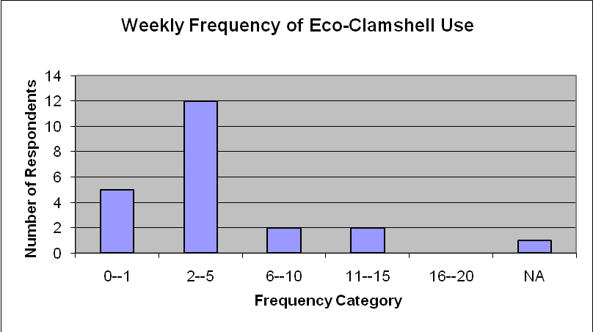

Figure 1. Weekly Frequency of Eco-Clamshell Use

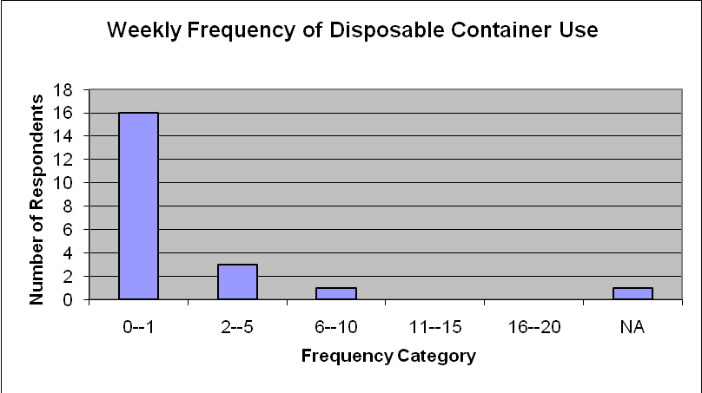

Figure 2. Weekly Frequency of Disposable Container Use

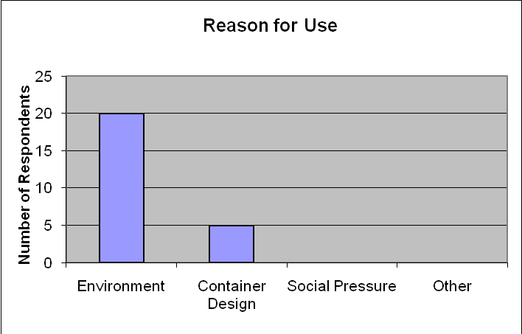

Figure 3. Reason for Use of Eco-Clamshell

Throughout project implementation we also gathered feedback from schools using the program. In the fall of 2008 we sent an e-mail to all of the accounts who had adopted the program or were looking into the system. We followed up this brief solicitation with a more in-depth survey sent to select accounts. Appendix 4 shows the survey form sent to specific schools. This feedback was interesting and provided insight into the various obstacles and successes at other campuses. Because the concept is new, many of them had to study the program and verify the results themselves. Some of the key obstacles encountered included the initial cost of purchasing a “fleet” of Eco-Clamshells and the set-up (administration) of the program. The cost calculator (Appendix 5) addresses the initial investment and the associated savings over time. The issues with cafeteria set-up have been solved through creativity. There are now numerous types of “accountability” models that a school might use. The accountability program varies widely by account.
In addition to surveys, we collected formative feedback on the containers, program, and marketing approach. Above in the “Prototype Production” section we already discussed use of some of the formative feedback for design. Other useful information had to do with the reusable system and how it is introduced to students. Based on feedback from other institutions, the best time to introduce the Eco-Clamshells is during the freshmen year, as the new students are registering for class. This makes the system part of the college experience from the beginning. It also allows students the opportunity to ask questions and become familiar with the concept. For many, the idea of checking a container in and out of the cafeteria is completely new. Students need to be coached so they are comfortable with the system and understand the logistics.

Marketing the Program
An important part of the reusable to-go program was effectively marketing the concept to the Eckerd College student body and other institutions. As mentioned above, advertising at registration increased participation exponentially. Social marketing also played an important role in these efforts. The program has a built-in social marketing component. That is, as students see their peers use an Eco-Clamshell, they are compelled to sign up. When Eckerd College started its program in the fall of 2007 we had approximately 200 students sign up. By the beginning of fall semester 2008, approximately 400 students were enrolled.
Marketing to institutions across the country had a similar trajectory. Initially a handful of very motivated campuses signed up for the program. These were schools that didn’t mind taking a chance and innovating in this area. The next set of schools to institute a program was motivated by and large by the prevalence of the system among peer institutions. This has contributed to the exponential growth of the reusable to-go model. As each new school establishes a reusable to-go program, other schools are similarly motivated.
There is also an element of competition in use of the Eco-Clamshell. Sustainability is an important factor in higher education and schools are constantly expanding their programs. For the admissions staff, sustainability is seen as a key selling point. It is not surprising that the majority of schools using the program are members of the Association for the Advancement of Sustainability in Higher Education. As an example of the exponential growth in this area, in the spring of 2009 approximately 80 schools were using the program. At present approximately 160 schools use the program and many more are in the evaluation stage for its use.
The same marketing strategy has worked effectively in the corporate realm. As well-known companies such as Google adopt the program, new locations are motivated to participate. Corporations also see sustainability as a way of creating a competitive advantage. A positive corporate image is important to retain a dedicated customer base and a talented workforce.
Another aspect of marketing the product has been the Eco-Clamshell calculator. This calculator (Appendix 5) allows the account to see the amount of money they will save by using the program. Although the price per a unit is $3-$5 instead of $.20-$.30, the payback is just ten to twenty uses. With the accountability model in place the cafeteria will save money by using the product and cover any losses by charging individuals for the misplaced units.
The last important marketing piece was the creation of the “Eco-Clamshell Handbook.” This Handbook (Appendix 6) walks an individual through the implementation stages--from meeting with the key stakeholders through selecting the appropriate accountability model.

Life Cycle Inventory and Comparative Analysis
To understand the impact of the Eco-Clamshell and how it compares to use of disposable units, a life cycle inventory and comparative analysis were conducted. This analysis is important to demonstrate that a reusable system not only reduces waste but also impacts other processes throughout the life cycle.
The process of reuse was found to increase total greenhouse gases emitted, kilowatt hours of energy used, and gallons of water used per Eco-Clamshell unit (Figure 4). These impacts occur during the dishwashing phase of the life cycle. For the life cycle analysis calculations, it was assumed that the Eco-Clamshell unit is reused an estimated 360 times (5 uses per week for two nine-month periods) before being retired to a traditional landfill (with no methane recovery).

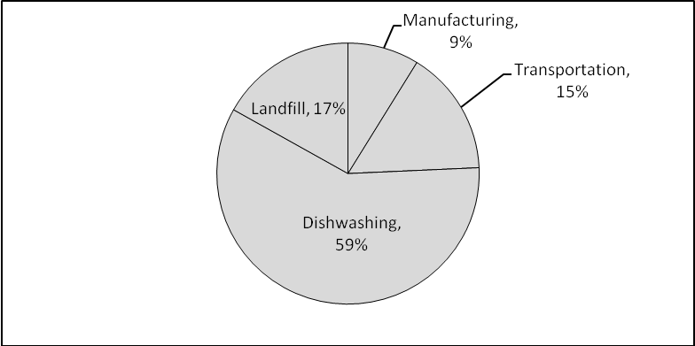

Figure 4. Proportion of greenhouse gases emitted by different life cycle phases for 360 uses of one Eco-Clamshell

Although the primary environmental impact of Eco-Clamshell use occurs during the dishwashing phase, this has to be measured against the benefits of reuse of the product for its anticipated life cycle, conservatively estimated to be 360 uses. In Table 1, the environmental impact associated with 360 medium foam containers is measured against one Eco-Clamshell. Each medium foam container weighs approximately 0.025 pounds. In all areas, except water, the need for 360 containers increases the amount of energy, greenhouse gases, and waste associated with the same purpose -- taking food to-go 360 times.

Table 1. Life cycle impact of 360 medium foam containers vs. one Eco-Clamshell

Container | Energy (kWh) | GHG (kg) | Solid Waste (lbs) | Water (gals)
1 Eco-Clamshell | 2 | 2 | 1 | 18
360 Medium Foam | 4 | 16 | 9 | 0

The above results were determined by assuming that one medium foam container is produced and transported in exactly the same fashion as the Eco-Clamshell. This was then adjusted using the average weight of one medium foam container. The foam container is approximately 4% of the weight of one Eco-Clamshell. Therefore, based on the available data, solid waste disposal is the most critical factor in the difference in life cycle impacts of the two containers. Figure 5 displays the greenhouse gases (landfill only) emitted by disposing 360 medium foam containers versus one Eco-Clamshell.

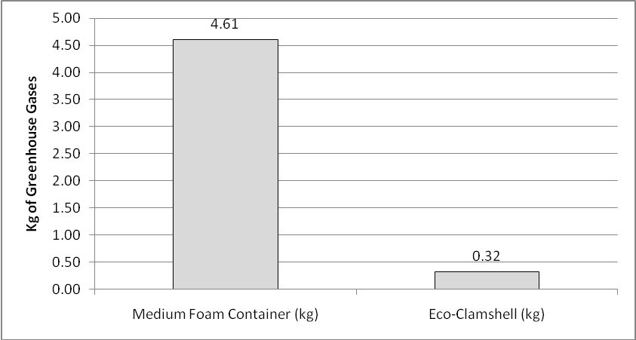

Figure 5. Greenhouse gases emitted for disposing 360 medium foam containers vs. one
Eco-Clamshell

In addition to these life cycle findings, we also explored the amount of waste diverted annually by the accounts using the Eco-Clamshell program. As of November 2009, 179,640 containers had been sold to institutions across the United States. Using the assumption that these containers replace 180 disposable units a year (5 days a week for 9 months), 32,335,200 disposable units were kept out of the landfill. In addition to the reduction in waste, this also represents a substantial reduction in the extraction of raw materials, energy use, and greenhouse gases.

Future and Conclusions
The purpose of this project was to develop a container prototype and reusable to-go system to be field tested at Eckerd College and then emulated by colleges and universities across the country. These goals have certainly been achieved. The Eco-Clamshells and reusable to-go program provide an innovative solution to disposable to-go container waste and minimize life cycle impact.
This project also started some initial investigation into a grocery store model, utilizing the least amount of packaging possible. It is fair to say that the majority of household waste comes from grocery store packaging -- everything is individually packaged and wrapped. The same reusable model could be incorporated into a grocery store chain by utilizing specially designed kiosks for return. The model would be a deposit and rebate system, with bulk bins and specially designed, reusable containers. Just like the Eco-Clamshells, this model would reduce waste and save the consumer money.

Materials and Methods
Surveys
The feedback surveys were conducted by selecting the target population and then sending an e-mail. These populations were Eco-Clamshell users at Eckerd College and other institutions using the program. The questions were both summative and normative in nature to gain feedback on the program. Appendices 3 and 4 show the survey questionnaires used in this study.

Life Cycle Analysis
To properly conduct the inventory and analysis, the procedures outlined under ISO 14040:2006 were used (International Standardization Organization). These procedures provide Life Cycle Analysis (LCA) guidelines to ensure the results are conducted scientifically and are as reliable as possible.
The functional unit for this study is one EC-O1 unit. This study is a gate-to-grave analysis. The extraction of raw materials (crude oil) is difficult to track and is therefore omitted from the study because of the lack of reliable data. The scope of the study includes production, transportation, reuse (dishwashing), and disposal. This study assesses four major impacts associated with the product: greenhouse gas emissions, landfill waste, energy, and water use.
A variety of calculation tools were used to complete the study; they include the Clean Air- Cool Planet Carbon Calculator, the EPA Greenhouse Commercial Dishwasher Calculator, and the GHG Protocol calculation database. Software developed specifically for a life cycle analysis was not used. Unlike analysis for most products, this was a relatively simple study because the EC-01 happens to be 100% polypropylene and the manufacturing technique (molded plastics) is rather simple. In addition, the boundaries of this study are narrowly defined to reflect the environmental impacts associated with just the containers. Other areas, such as packaging or machinery maintenance, were not included.
A number of pieces of data and calculations were used in this study. Appendix 7 displays the various data points, assumptions, and calculations used.
One significant limitation to this study is the inability to properly account for the extraction of raw materials. A cradle-to-grave analysis would provide a more holistic picture of the product. That being said, the use of the Eco-Takeouts significantly reduces the amount of material extracted from the environment. Other limitations include the assumptions listed in Appendix 7. Each scenario for the Eco-Takeouts will be different; therefore some standards had to be created in order to conduct a life cycle analysis. For example, if the containers last for 5 years, then the comparative analysis is measurably improved. Another limitation is the lack of access to life cycle analysis software. The interpretation and measurement of various factors could be more in-depth by utilizing such software.
Based on all factors that we have used to measure the effectiveness of use of this new product, as well as its positive impact on the environment, we consider use of the product to be effective for its intended purposes. We hope to continually improve the product, thereby making it a sound method for addressing a serious issue in a culturally acceptable format.

Acknowledgements

First and foremost we would like to acknowledge the Environmental Research and Education Foundation. Without their generous support this project would not have been possible. We would also like to acknowledge all of the students, staff, and faculty at Eckerd College who supported the Eco-Clamshell concept and were willing to try something new. Lastly we would like to thank G.E.T. Enterprises for their willingness to embrace a new product and develop and sell the concept.

References

Alken Murray Corp. “Ocean Shipping Container Capacities.” 8 Dec. 2009. http://www.alken-murray.com/OceanContainer.pdf

Clean Air-Cool Planet. “Clean Air-Cool Planet Carbon Calculator.” 8 Dec. 2009. http://www.cleanair-coolplanet.org/toolkit/inv-calculator.php

“Energy in China: Transportation, Electric Power and Fuel Markets.” Asia Pacific Energy Research Centre. (2004): 9-10

Environmental Protection Agency. “Commercial Dishwasher Calculator.” 8 Dec. 2009.
www.energystar.gov/ia/business/.../CalculatorCommercialDishwasher.xls

Franklin Associates LTD. “Life Cycle Inventory of Polystyrene Foam, Bleached Paperboard, and Corrugated Paperboard Foodservice Products.” Polystyrene Packaging Council. (2006): 1-50.
“GHG emissions from transport or mobile sources.” The Greenhouse Gas Protocol Initiative. 8 Dec. 2009. http://www.ghgprotocol.org/calculation-tools/all-tools

International Standardization Organization. “Environmental management-Life cycle assessment- Requirements and guidelines.” (2006): 14044

“Model EST44H Spec Sheet.” CMA Dishmachines. (2009): 1-2

National Geographic. “Plastic Container Buying Guide.” The Green Guide. 8 Dec. 2009. http://www.thegreenguide.com/buying-guide/plastic-containers

Appendices

Appendix 1: Eco-Takeout Series

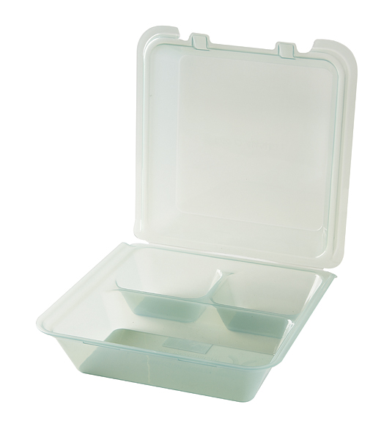 | 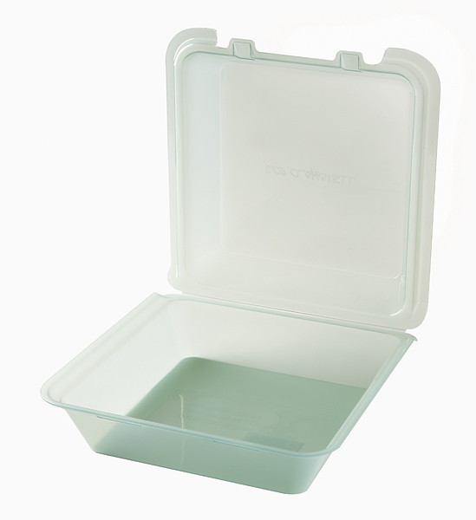 | 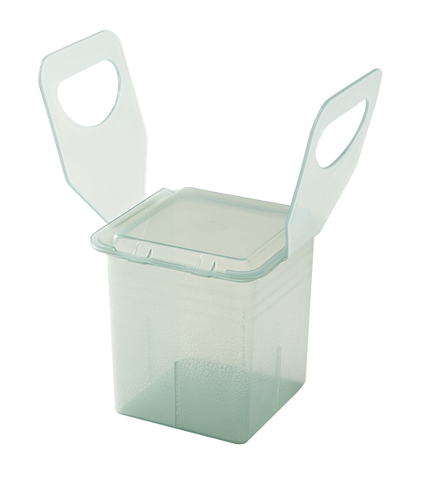
EC-01 | EC-02 | EC-03
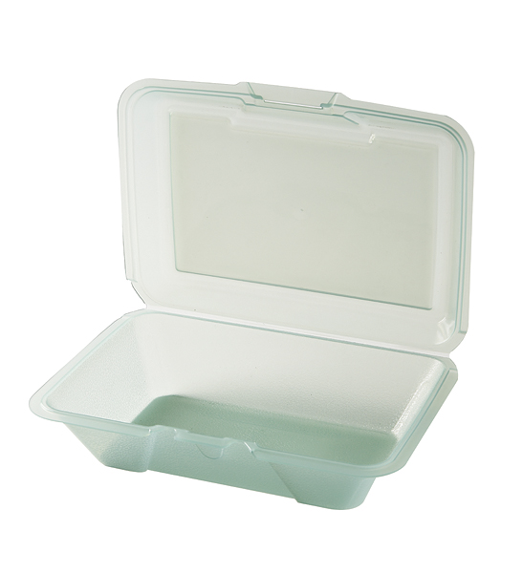 | 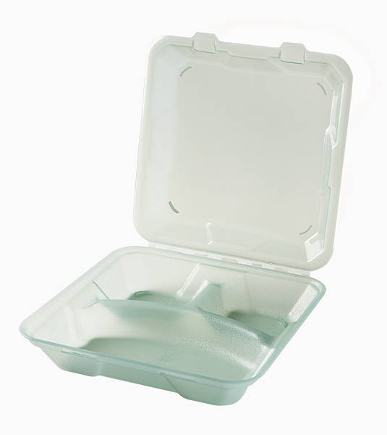 | 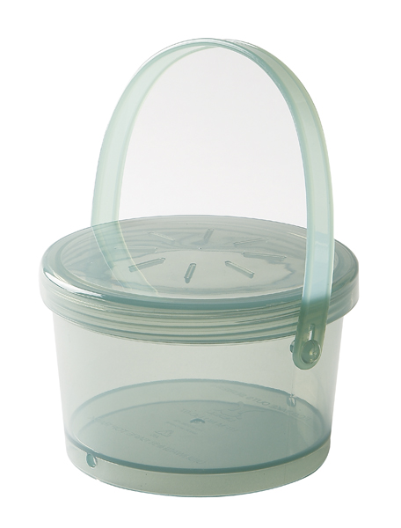
EC-04 | EC-06 | EC-07

*EC-05 was discontinued

Appendix 2: Eco-Clamshell Adoption Locations throughout North America

Western United States

*Colorado
Colorado State College
*Arizona
ASU University- Downtown
Arizona State University
*Washington
Bellarmine Prep School
Evergreen State College
*Oregon
Pacific University
Southern Oregon University
*California
California State University- Bakersfield
California State University- East Bay
Claremont McKenna College
Hope International University
Humboldt State University
Mills College
Mills College
Pitzer College
Point Loma Nazarene University
Pomona College
Santa Clara University
Scripps College
*Idaho
Boise State University
*New Mexico
St. John's University
University of New Mexico
*Alaska
University of Alaska- Anchorage
University of Alaska- Fairbanks

Central United States

*South Dakota
Dakota State University
Dakota Wesleyan University
Mount Mary College
Northern State University
South Dakota State University
*Nebraska
College of St. Mary
St. Thomas University
*Oklahoma
University of Tulsa
*Texas
Abilene Christian University
Austin College
Baylor University
Sam Houston State University
Southern Methodist University
Texas A&M University Corpus Christi
University of Houston
University of Saint Thomas
University of Texas @Tyler
University of Texas Austin
*Minnesota
Augsburg College
Bemidji State University
Bethel University
Macalester College
Southwest Minnesota State University
*Iowa
Loras College
*Arkansas
Harding University
John Brown University
Southern Arkansas University
*Mississippi
University of Mississippi
University of Southern Mississippi
*Kentucky
Kentucky State University
Morehead State University
Sayre School
*Illinois
Knox College
Monmouth College
Northwestern University
University of Illinois- Spring field
*Wisconsin
Lawerence University
University of Wisconsin
*Michigan
Concordia University
Grand Valley State University
*Ohio
Capital State University
Cincinnati Christian University
John Carroll University

Eastern United States

*New Hampshire
Southern New Hampshire University
*New York
Avila University
Clarkson University
LIU CW Post
NYU Hayden Hall
Rochester College
SUNY- Plattsburgh
Syracuse University
Vassar College
*Massachusetts
Massachusetts Institute of Technology
Regis College
*Connecticut
University of Hartford
Wesleyan College
*Pennsylvania
Bloomsburg University
East Stroudsburg University
Lehigh University
Millersville University
Philadelphia University
Sain Joseph's University
Slippery Rock University
Westchester University of Penn.
*Maryland
Frostburg State University
John Hopkins University
Maryland Institute of Art
University of Notre Dame
Washington College
*Delaware
Delaware State University
Wesley College
University of Delaware
Western Virginia
Glenville State College
*Virginia
College of William and Mary
Ferrum College
James Madison University
Longwood University
Old Dominion University
University of Richmond
University of Virginia
Virginia Commonwealth University
*North Carolina
Duke University
East Carolina University
Fayettville State University
Meredith College
Peace College
Queens University
UNC School of the Arts
University of North Carolina
Wake Forest University
*South Carolina
Erskine College
Furman University
Winthrop College
*Georgia
Agnes Scott College
*Alabama
Auburn University
University of Alabama
*Florida
Eckerd College
Embry Riddle Areo University
Palm Beach Atlantic University
St. Thomas University
Stetson University
University of Central Florida
University of Florida
University of South Florida
*Tennessee
Maryville School System
Mt. Juliet Middleschool
Union University
University of Nashville
University of Tennesse @Martin

Canada

*Ontario
Bishop Strachen School
Branksome Hall
Canadian Memorial Chiropractic College
Carleton University
Kings University College
Ryerson University
Thunder Bay College
Trent University
University of Toronto
UTSC
Wilfrid Laurier University
*British Columbia
University of British Columbia
*Alberta
University of Alberta
*Novia Scotia
Saint Mary's University
*Manitoba
St. John's Ravenscrout
*New Brunswick
St. Thomas University

Corporations

Name | State
Applied Biosystems/Fitness Center | CA
Daymon Corporation | CT
Disney Studios | CA
Edgewater Beach Resort | FL
Google | CA
Guckenheimer Aeropace | CO
Hewlett Packard Catering | CA
Nestle | CA
Nylo Plano at Legacy | TX
Vogue Magazine | NY

Healthcare

Name | State
Casa de Las Campanas | IL
Mendota Community Hospital | CA
Morrison & White Sands La Jola | CA
Diamond Terrace | CA
Mennonite Village | CA
Westminster Garden | CA
St. Anthony’s Medical Center | MO
Virginia Baptist Hospital | VA
Waterford Life Care Retirement Community | FL
Westminster Palms | FL
Westminster Asbury | FL

Appendix 3: Eco-Clamshell Student Survey Questionnaire

How frequently do you use an Eco-Clamshell container on a weekly basis?

0-1 | 2-5 | 6-10 | 11-15 | 16-20

How frequently do you use a disposable container on a weekly basis?

0-1 | 2-5 | 6-10 | 11-15 | 16-20

Why do you use the Eco-Clamshell? (Please check all that apply.)

Environment | Container Design | Social Pressure | Other (please write below)

If there are other reasons, please explain.

Have you ever lost an Eco-Clamshell container?

Yes No

If you purchased additional Eco-Clamshell containers, why was this?

Replacement | Additional Mobility* | Other (please write below)
* If you have two containers this gives you the ability to check a container out while one is in your room/fridge.

If there are other reasons, please explain.

Are there features of the container design that you would change? If so, please explain.

Are there aspects of the accountability system that you would you change? If so, please explain.

Please provide any additional comments, suggestions, or feedback.

Appendix 4: Eco-Clamshell Comparative Analysis Survey

- Total number of Eco-Clamshells purchased.
- Total number of individuals enrolled in the program.
- Approximate start date of the program.
- Total applicable population (number of individuals who could use the program).
- Why your institution decided to implement the Eco-Clamshell program.
- Any issues encountered during the implementation process.
- The type of accountability system your institution decided to use.
- Population reaction to the program.
- Anticipated program direction.
- Any other reflections on the program.

Appendix 5: Cost Calculator
DISPOSABLE SYSTEM ANNUAL COST
# of Disposable Units Purchased Annually
Price Per Unit
External Costs (landfill, labor)
Total Cost | $ -
ECO-TAKEOUT SYSTEM Initial Cost
Initial Units Purchased
Price Per Unit
Total Cost | $ -
ECO-TAKEOUT SYSTEM- 1st Yr Savings
Initial Investment Cost | $ -
External Costs (dishwashing, labor)*
Disposables Cost (estimated at 50%) * | $ -
Total Sales (if sold to population) | $ -
Net Cost | $ -
Savings compared to disposables | $ -
ECO-TAKEOUT SYSTEM- Savings 2nd Yr
Replacement Costs (estimated at 5% of total) | $ -
External Costs (dishwashing, labor)*
Disposables Cost (estimated at 30%)* | $ -
Net Cost | $ -
Savings Compared to Disposables | $ -
ECO-TAKEOUT SYSTEM- Savings 3rd Yr
Replacement Costs (estimated at 5% of total) | $ -
External Costs (dishwashing, labor)*
Disposable Cost (estimated at 10%)* | $ -
Net Cost | $ -
Savings Compared to Disposables | $ -
Appendix 6: Eco-Clamshell Handbook
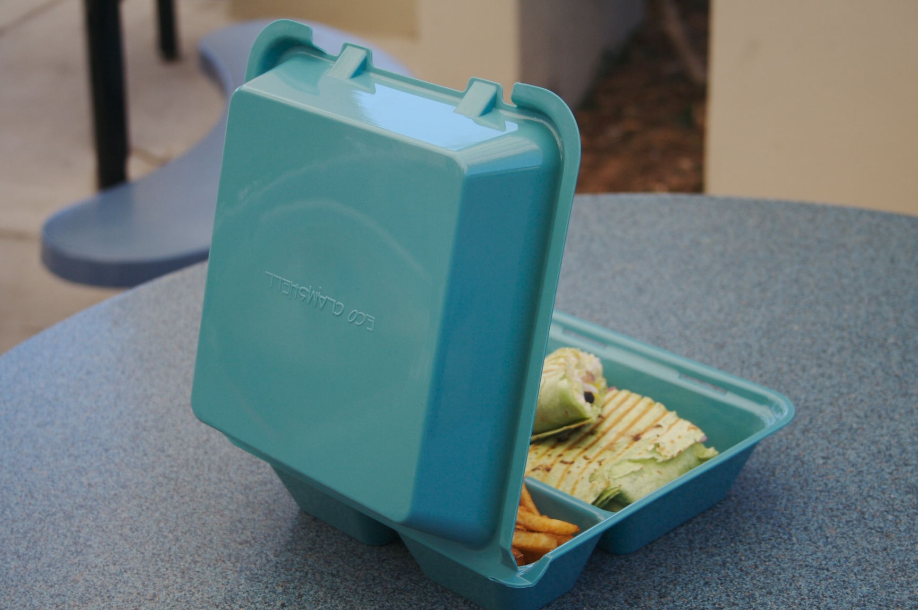

Eco-Clamshell Handbook
How to Implement a “Reusable To-go Program”
September 2009

For more information please contact Audrey Copeland,
Eckerd College Environmental Studies program graduate 2007,
GET Sustainable Products Manager, at
acopeland@get-melamine.com or 213-500-6320


www.eckerd.edu

Table of Contents
Section | Page Number
- Eco-Clamshell: Founded at Eckerd College  - Steps to Implement a Reusable To-go Program | 2  3
- Step#1 Meet With Key Individuals | 4
- Step#2 Choose an Accountability System | 5
- Step#3 Purchase Containers | 8
- Step#4 Program Implementation and Growth | 10
- Step #5 Evaluate Program | 11
- References & Media Coverage | 12
- Eco-Clamshell Adopters | 13
- Other  Sign-up Example  Eco-Clamshell Lifecycle Chart | 14  15

Eco-Clamshell: Founded at Eckerd College
In the fall of 2004 Audrey Copeland conducted an audit for Professor Ormsby’s Introduction to Environmental Studies class. From this audit she became aware of the immense amount of Styrofoam (polystyrene waste) going to the landfill every year. There had to be a solution! This turned out to be a reusable system utilizing a durable container that circulates in a closed loop fashion.
In July of 2007 the Environmental Research and Education Foundation awarded Eckerd College a $32,000 grant to develop and implement the program at locations across the nation. In the fall of 2007 G.E.T. Enterprises, a Houston-based manufacturer, agreed to construct a prototype. In the spring of 2008 the containers went live at Eckerd College. Now the containers are in use at hundreds of universities, retirement centers, and corporate accounts across the nation. Not only does the program provide an eco-friendly solution but it saves money, demonstrating that sustainable solutions can also be good for the bottom line.

Steps to Implement a Reusable To-go Program
Step #1: Meet with key individuals
Examples:
- cafeteria manager
- sustainability coordinator/advocate
- business office/accounting representative
- information technology representative
- student focus group

Step #2: Establish the desired system of accountability

Step #3: Determine necessary amount and purchase containers

Step #4: Implement system and focus on continued growth

Step #5: Evaluate Program

Step #1: Meet With Key Individuals
The first step is to meet with the key individuals at your institution. This includes the cafeteria manager, students, faculty, a sustainability advocate, a representative from the business office, and an individual from the information technology department. You will need the support of all these individuals to set-up a program.
Organize a meeting and come prepared with a preliminary cost-benefit analysis (cost of disposables each year vs. cost of Eco-Clamshells), an outline of the environmental benefits, examples of other institutions using the program, and a proposal for the possible accountability model. You should also consider conducting a student survey to demonstrate the enthusiasm for the program. In the initial survey I conducted, 81% of students stated that they would use the container. This was helpful when I proposed the program to the cafeteria manager.

Step #2: Choose an Accountability System
Below are three accountability systems, although there are many other possibilities. The cafeteria setting will dictate the type of accountability system. Most importantly there must be some form of accountability. Whether students pay up front or for the loss of a container, it is essential that responsibility is built into the program. If not, the containers will be gone in a short period of time (“tragedy of the commons”).

Card for Container System of Accountability
- Students sign up at the front of the cafeteria. At this time they write down their student ID number and consent to a charge of a certain amount ($X) to enter the program.
- This information is sent to the Business Office in an excel spreadsheet so the charge can be applied to the student’s account.
- Each time the student returns a container they will receive a container token/container. Each time they check out a container, they will turn in their container token/container. An example of a token is a key tag with a picture of an Eco-Clamshell on it.
- When students return a container, they place this item on the dishwasher conveyor where it can be sanitized and put back out for reuse.
- If a student loses either the container or the token, they will need to sign up for the program again and pay an additional $X.
- The money generated from containers will be placed in an account. This account will be used to purchase replacement containers.
Swipe System of Accountability
- Students use their ID card to check out containers at the front of the cafeteria.
- A reminder e-mail notification is sent to the student after a set period of time (24-48 hours).
- After another 24 to 48 hours, following this reminder e-mail, students are charged for the container (if it’s not returned).
- Students bring the container back to the cafeteria. At this point their student card is swiped again to indicate that the container has been returned.
- When students return a container, they place this item on the dishwasher conveyor where it can be sanitized and put back out for reuse.
- The money generated from lost containers will be placed in a restricted account. This account will be used to purchase new containers.

Barcode System of Accountability
- Students sign up for the program and receive a card with a barcode number. The barcode would be linked to their information in a database (think of CVS or Costco card).
- A reminder e-mail notification is sent to the student after a set period of time (24-48 hours).
- After another 24 to 48 hours, following this reminder e-mail, students are charged for the container (if it’s not returned).
- Students bring the container back to the cafeteria. At this point their barcode is scanned again to indicate that the container has been returned.
- When students return a container, they place this item on the dishwasher conveyor where it can be sanitized and put back out for reuse.
- The money generated from lost containers will be placed in a restricted account. This account will be used to purchase new containers.

Advantages and Disadvantages
Each method of accountability has certain advantages and disadvantages. The easiest program to implement is the exchange model. This doesn’t require any programming or computer set-up. The drawback is that students aren’t required to return the containers in a certain time frame (inventory). In addition they can’t check-out more than one container at a time. The other two models allow for more exact tracking and monitoring but take a little more time to set up. The swipe system requires some programming. The barcode system necessitates the purchase of specific equipment. In both cases students can check out multiple containers, within an acceptable duration for check-out. These advantages and disadvantages should be considered when setting up a program.

Step #3: Purchase Containers
The quantity of containers that should be purchased obviously depends on the number of individuals on the meal plan. Frequency of use should also be considered. The same survey conducted to gauge student interest can also include a question about to-go container use. This will provide an overall estimate. You want to make sure there are enough containers to service the student body, given that some will be in circulation at all times. If the majority of students take food to-go three times daily, this is important information to know.

Cost-Benefit Analysis
Another aspect to consider when purchasing the containers is the cost-benefit analysis. Although the containers require an initial investment, this is balanced by long-term savings. Not only is this program environmentally sustainable, but it’s also good for the bottom line.
Here is an example of how this was determined at Eckerd College. On average we spend $10,000 a year on disposable containers. To purchase a sufficient number of Eco-Clamshells for the entire cafeteria population, we would need to spend $3,600 ($3.6x1,000). $3.60 is the cost of one Eco-Clamshell unit and we have 1,000 students on the meal plan. If everyone taking food to-go uses the Eco-Clamshell, there is a net savings of $6,400 ($10,000-$3,600). If only half the campus population uses these containers for 100% of there to-go use, there would be a savings of $1,400 the first year ($10,000- ($5,000+$3,600)).
During the second year additional savings would occur due to the self funding nature of the program. Students are paying for the containers. Depending on the model students either purchase the container up front or pay for the loss of the container. If everyone used the containers the second year there would be a net savings of $10,000. If only half the campus population used these containers, $5,000 would be saved.
It should be noted that the above analysis doesn’t take into account the costs associated with washing the containers and training personnel to manage the program. At Eckerd we found these costs to be of minimal significance. Our dishwasher operates at a high level of efficiency and loads are pushed through the dishwasher on a conveyor belt, regardless of whether they are full. In other words adding some additional dishware doesn’t affect the frequency of the cycles. In addition, training personnel proved to be a one-day process. To factor these costs into the analysis, determine the water and energy used for one cycle and divide this by the number of containers that can be placed in the dishwasher. This should be factored into the analysis and could result in hidden costs, depending on the dishwasher system.

Where to Source a Container
The best way to source containers for your cafeteria account is to go through your supplier as you would for any item. Your supplier should be able to source Eco-Clamshell containers for you. If this fails, contact G.E.T. Enterprises and they will connect you with a local source (getinc@get-melamine.com).
If you aren’t a cafeteria account, search for “Eco-Clamshell” on the internet and some options will pop up. This is also a good approach if you need a small amount of containers.

Step #4: Program Implementation and Growth
Implementing the program is probably one of the most important steps. The best approach is to involve a variety of student groups. Have members of an environmental club in the cafeteria for the first couple of weeks to explain and market the program. Engage the student government and encourage them to make a commitment to using the containers. Send out an e-mail blast to various campus groups, create signs to display in the cafeteria, and ask the cashier to market the program each time they hand out a disposable container. The more buzz you create around the concept, the more users you will have. Keep in mind that the program also markets itself as students walk around the campus with reusable containers.
Make sure to carefully explain how the accountability system works. Regardless of the system you use it is advisable to create a terms of use sheet that students are handed when they sign up. The more information they have the better.
It’s also advisable to send out a press release. This concept is new and innovative and chances are the local media will be interested. Good press is never a bad thing for an institution.
Each year the reusable to-go program should be presented to incoming freshman at registration. If they have the option to sign-up right there chances are they will. Eventually the program will be a part of the campus culture, to the extent that disposable containers can be phased out entirely.

Step #5: Evaluation
Another important part of the implementation process is program evaluation. This should include a student survey and an evaluation of program success from the viewpoint of multiple stakeholders (cafeteria employees, college staff, faculty etc...). It’s especially important to conduct this evaluation following the first six to twelve months of operation.

References/Media Coverage
“Going Green One Meal at a Time”. Video Clip. Fox 13. 1 May 2008. <http://www.myfoxtampabay.com/dpp/about_us/Going_green_one_meal_at_a_time>

“To-Go Containers Keep Going”. Ed. Judy Stark. Saint Petersburg Times. 19 April 2008. <http://www.tampabay.com/features/homeandgarden/article461872.ece>

Goodall, Hurley. “At Eckerd, Eco To Go”. The Chronicle of Higher Education. 18 April 2008. <http://chronicle.com/blogs/architecture/2029/at-eckerd-college-eco-to-go>

“An Eco-friendly kind of doggy bag for college students”. Article and Video. Bay News 9. 15 April 2008. <http://www.baynews9.com/content/36/2008/4/15/340139.html>

“Eckerd College Switches to Reusable To-Go Containers”. Association for the Advancement of Sustainability in Higher Education. 10 April 2008. <http://www.aashe.org/archives/2008/0410.php#6>

“An Alternative to Throwaway Food Containers”. The Ledger. 9 April 2008. <http://environment.theledger.com/default.asp?item=2185464>

Liberman, Melissa “Environmental caring in, carry out boxes”. Article. Channel 10 News. 7 April 2008. <http://www.wtsp.com/news/local/story.aspx?storyid=77725>

“Eckerd College Introduces Sustainable EcoClamshell Container”. Tampa Bay Business Journal. 4 April 2008. <http://tampabay.bizjournals.com/tampabay/stories/2008/03/31/daily55.html?b=1207281600^1616063&surround=etf

Blogs and Other Coverage

“Take your food to go without guilt”. Ode Magazine. 7 May 2009. <http://www.odemagazine.com/exchange/7325/take_your_food_to_go_without_guilt?utm_source=Ode+Newsletters&utm_campaign=12c82328c9-Weekly_Newsletter_0512095_11_2009&utm_medium=email>

Anstett, Michelle. “Knox scrubs trays, Styrofoam from cafeteria”. Galesburg.Com. 12 September 2008. <http://www.galesburg.com/education/x1213463418/Knox-scrubs-trays-Styrofoam-from-cafeteria>

“To-Go Containers at Eckerd are First in Florida To Go Green”. Ed. Jack Bevilacqua. Florida Gulf Coast Chapter Newsletter. May 2008.
<http://fgcc.roundtablelive.org/Content/Documents/Document.ashx?DocId=17079>

Adopters
To date, 116 colleges have adopted the program or are in the implementation process. Below is a list of campuses that have officially adopted the program.
Washington College  Baylor University  University of Wisconsin  University of Mississippi  University of Florida  Emory College  University of Richmond  University of Tulsa  University of Tennessee  UNC-Ashville, Charlotte, Top of Lenoir  Syracuse College  Stetson University  University of New Mexico  Southern New Hampshire University  Knox College  Slippery Rock University  Maryland Institute of Art | Bethel University  Humboldt State University  Florida International University  Eckerd College  Dobbs School  Santa Clara University  Mills College  Knox College  MIT  Macalester College  Meredith College  Sayre School  Notre Dame  Peace College  Morrison at Westminster Garden  Mt Juliet Middle School  Meredith College

Sign-up Example
The EcoClamshell is an invention to replace the use of disposable to-go containers in a cafeteria setting. The EcoClamshell has been designed to withstand heavy use; in addition, the container can go in a high heat dishwasher and a microwave. The cost to enroll in this program is $5.00. This allows you to check-in and check-out containers throughout the academic year. By completing and signing below you are authorizing the $5.00 fee assessed to your student account.
Name | ID Number | Signature |  |  | Date

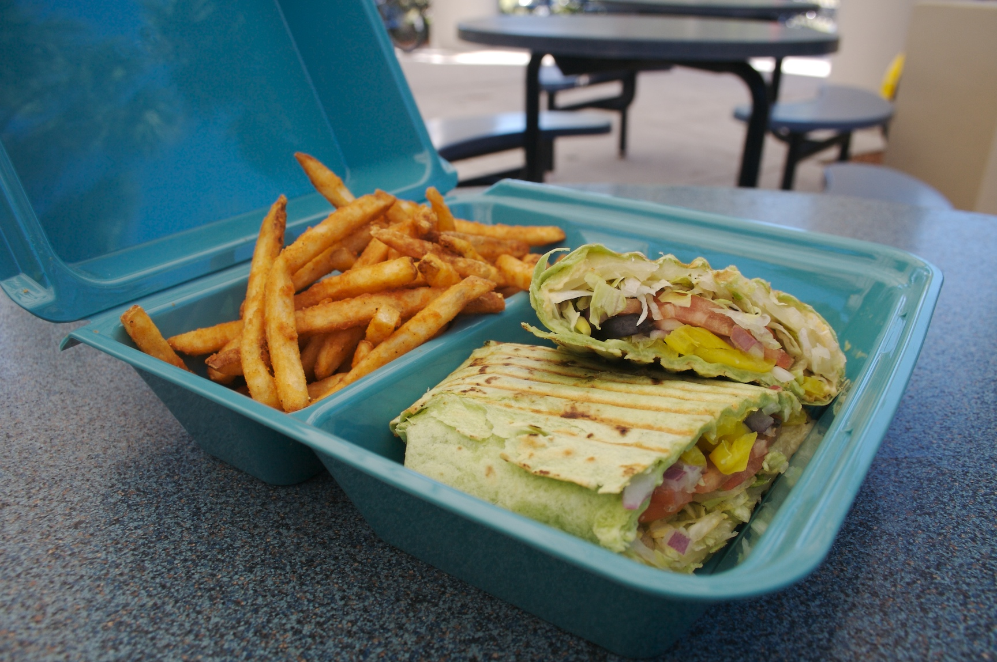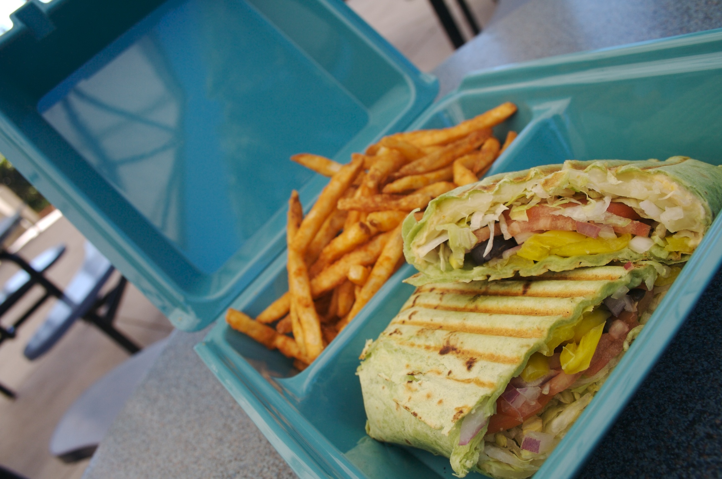

Eco-Clamshell Lifecycle Chart

Production | Distribution | Reuse |  | Recycle
 |  |  |  | 
- The Eco-Clamshell is manufactured in a factory that uses energy and produces waste and greenhouse gases.  - The amount of energy used and waste produced depend on the factory’s operating procedures.  - The Eco-Clamshell is produced less frequently than disposable polystyrene containers, cutting down on the production process. | - The Eco-clamshell is distributed to a location for use.  - The amount of energy and greenhouse gases produced depends on the length of travel and mode of transportation (i.e. train, air etc...).  - The Eco-Clamshell is shipped less frequently, minimizing the environmental impact of distribution. |  | - The Eco-Clamshell is used by individuals and then returned to be sanitized in a high-heat industrial dishwasher.  - The amount of energy and water resources used depends on the machine.  - Industrial strength dishwashers are extremely energy and water efficient due to their quick cycle. |  | - At the end of the Eco-Clamshell’s lifetime the container is retired to a recycling facility that accepts #5 plastic.  - The amount of greenhouse gases and energy used depend on the type of facility, the length of travel, and mode of transportation.

Appendix 7: Eco-Clamshell Life Cycle Analysis Data and Calculations

Manufacturing Data
- China’s energy mix as a national average is 69.8% coal, 24.7% oil, 2.9% gas, 2.4% hydro (Energy in China, 9)
- 1 EC-01 weighs .58 lbs
- Material is 100% polypropylene
- 1 production run
  - consists of 1900 containers
  - takes 24 hours to produces
  - uses 492 kWh over a 24 hour period (20.5 kWh used to operate machine)
Transportation Data
- The port of entry is Long Beach California
- From China to Long Beach, CA the boat travels approximately 6,260 miles
- The distance between Long Beach, CA and Houston, TX is approximately 1,360 miles or 2,189 kilometers
- The containers are shipped, already in a box, in a 40 foot container measuring 474x96x92 inches (Ocean Shipping Container, 1)
- Each box of Eco-Takeouts measures 19x10x7.75 inches and contains 12 containers
- A standard 40 foot containers, if loaded to the maximum contains 2,843 boxes for a total of 34,116 Eco-Takeouts
- The emissions factor for ocean freight is .06 metric tons of GHG’s per ocean mile (GHG Emissions from Transport, 4)
- The emissions factor for a light weight freight truck is 400 grams of GHG’s per 1kilometer (GHG Emissions from Transport, 4)
- All product ships directly to Houston, Texas before continuing on to its final destination
Dishwashing Data
- Energy star rated CMA model EST-44H used for study
- Uses 43,346 kWh per year (Model EST44H, 1)
- 243 racks per hour (Model EST44H, 1)
- .49 gallons of water per rack (Model EST44H, 1)
- The peg rack used in this study measures 20x20 inches

The following assumptions were made in this study:

Transportation
- A 40 foot container filled with EC-01’s accounts for an estimated 2% of the total GHG’s associated with ocean freight
- After reaching the Houston, Texas warehouse the product travels approximately 500 miles
- The product travels 20 miles to reach a recycling, landfill, or waste to energy facility
- Product is shipped via a lighter weight truck
Dishwashing
- The product is washed in a high temp, conveyor, energy star commercial dishwasher
- 100% electric power is used for the dishwasher (no gas)
- A 20x20 peg rack can hold 10 Eco-Takeout containers
- The dishwasher is running 10 hours per day
- The product is kept in circulation for 2 years at a rate of 5 uses per week during a standard school year (9 months). In total the product is used and washed 360 times before being retired to a landfill facility

Calculations
Manufacturing Calculations
- kWh per EC-01= 492 kWh/1900 units= .26 kWh
- GHG’s (kg) per production run= 313.6 (Clean Air-Cool Planet Carbon Calculator)
- GHG’s per EC-01= 313.6/1900= .17 kg per EC-01
Transportation Calculations
- Cubic inches 40 ft container= 474x96x92= 4,186,368 cubic inches
- Boxes of EC-01’s per container= 19x10x7.75= 1472.5 cubic inches= 2,843 boxes
- Eco-Takeouts per 40 foot container= 2843 boxesx12= 34,116 Eco-Takeouts
- GHG’s for ocean freightliner= .06x6260 mi.= 375.4 metric tons of GHG’s
- Percentage of ocean freightliner used for 40 ft container= 375.6x.02= 7.512 metric ton or 7,512 kg of GHG’s
- kg of GHG’s per EC-01 ocean freightliner= 7,512/34,116= .22 kg per EC-01 for ocean freight
- GHG’s (grams) road freight Houston, TX= 400x2188.7= 875,480 grams of GHG’s or 875.48 kg of GHG’s
- Kg of GHG’s per EC-01 road freight Houston, TX= 875.48/34,116= .03 kg per EC-01
- GHG’s (grams) road freight final destination= 400X804.67= 321,868 grams of GHG’s or 321.87 kg of GHG’s
- Kg of GHG’s per EC-01 road freight final destination= 321.87/34,116= .04 kg per EC-01
- Total GHG’s per EC-01= .22+.03+.04= .29 kg of GHG’s
Dishwashing (reuse) Calculations
- Gallons per EC-01= .49 gallons/10 EC-01’s= .05 gallons
- Gallons per EC-01, 360x= .05x360=17.64
- kWh per day= 43,346 kWh/365 days= 118.76 kWh
- Racks per Day= 243x10 hours= 2,430 racks
- EC-01’s per day= 2,430x 10 units per rack= 24,300 EC-01’s
- kWh per EC-01= 118.76 kWh/24,300 EC-01’s= .0049 kWh
- kWh 360x= .0049x360= 1.76
- Kg of GHG’s per EC-01= 1.1 (Clean Air-Cool Planet Carbon Calculator)
Landfill Calculations
- Grams of GHG’s transportation= 400x32.19 kilometers= 12,876 grams
- Kg of GHG’s transportation= 12,876/1000= 12.88 kg
- Kg of GHG’s per EC-01 transportation= 12.88/34,116.41= .0004 kg
- Short tons of waste per production run= 1900x.58= 1102 lbs/2000= .551
- Metric tons GHG’s per production run= .6 (Clean Air- Cool Planet Carbon Calculator)
- Kg GHG per EC-01= .6/1000/1900= .32
- Total Kg of GHG’s per EC-01= .0004+.32= .3204

Appendix 8: EcoClamshell Media Coverage
Print Media
Guzik, Hannah. “Takeout, eco-style.” Ashland Daily Tidings. 5 November 2009.
http://www.dailytidings.com/apps/pbcs.dll/article?AID=/20091105/NEWS02/911050315/-1/NEWS01

“Wilfrid Laurier University Introduces Reusable Plastic Food Container.” Association for the Advancement of Sustainability in Higher Education. 5 October 2009. http://www2.aashe.org/archives/2009/1005.php#20

“Aramark Introduces Reusable To-go Containers on Campuses.” Restaurants and Institutions. 25 August 2009. http://www.rimag.com/article/CA6685675.html

“To-Go Containers Keep Going”. Ed. Judy Stark. Saint Petersburg Times. 19 April 2008. <http://www.tampabay.com/features/homeandgarden/article461872.ece>

Goodall, Hurley. “At Eckerd, Eco To Go”. The Chronicle of Higher Education. 18 April 2008. <http://chronicle.com/blogs/architecture/2029/at-eckerd-college-eco-to-go>

“An Eco-friendly kind of doggy bag for college students”. Article and Video. Bay News 9. 15 April 2008. <http://www.baynews9.com/content/36/2008/4/15/340139.html>

“Eckerd College Switches to Reusable To-Go Containers”. Association for the Advancement of Sustainability in Higher Education. 10 April 2008. <http://www.aashe.org/archives/2008/0410.php#6>

“An Alternative to Throwaway Food Containers”. The Ledger. 9 April 2008. <http://environment.theledger.com/default.asp?item=2185464>

Liberman, Melissa “Environmental caring in, carry out boxes”. Article. Channel 10 News. 7 April 2008. <http://www.wtsp.com/news/local/story.aspx?storyid=77725>

“Eckerd College Introduces Sustainable EcoClamshell Container”. Tampa Bay Business Journal. 4 April 2008. <http://tampabay.bizjournals.com/tampabay/stories/2008/03/31/daily55.html?b=1207281600^1616063&surround=etf>

Video, Blogs and Other Coverage

Kuck, Paul. “Campus Dining Trends.” The Sustainable Shift Drink. 27 October 2009. http://www.sustainablefoodservice.com/blog/campus-dining-trends/

“Take your food to go without guilt”. Ode Magazine. 7 May 2009. <http://www.odemagazine.com/exchange/7325/take_your_food_to_go_without_guilt?utm_source=Ode+Newsletters&utm_campaign=12c82328c9-Weekly_Newsletter_0512095_11_2009&utm_medium=email>

“Going Green One Meal at a Time”. Video Clip. Fox 13. 1 May 2008. <http://www.myfoxtampabay.com/dpp/about_us/Going_green_one_meal_at_a_time>

Anstett, Michelle. “Knox scrubs trays, Styrofoam from cafeteria”. Galesburg.Com. 12 September 2008. <http://www.galesburg.com/education/x1213463418/Knox-scrubs-trays-Styrofoam-from-cafeteria>

“To-Go Containers at Eckerd are First in Florida To Go Green”. Ed. Jack Bevilacqua. Florida Gulf Coast Chapter Newsletter. May 2008.
<http://fgcc.roundtablelive.org/Content/Documents/Document.ashx?DocId=17079>

Gieson, John. “ICUF report- Eckerd student invents reusable green take-out containers”. Independent Colleges and Universities in Florida Report. May 2008.
<http://www.icuf.org/_resources/newsletters/ICUF_Report_May_2008.pdf>

Brode, Matt. “Florida Student Pioneers Eco-friendly Take-out”. News 4 Tucsan, Arizona. <http://www.kvoa.com/global/story.asp?s=8531465>

“Green Containers, Weddings, and More”. The Daily Green Blogspot. 19 May 2008. <http://thedailygreen.wordpress.com/>

Sullivan, Nicole. “Eco-Clamshell”. Northwest Arkansas Home Page. Online Video Clip. 16 May 2008. <http://nwahomepage.com/content/fulltext_green?cid=12995>

“Reusable Take-Out Containers Emerge on College Campus”. 5 May 2008. Ozarks First. Online Video Clip. <http://ozarksfirst.com/content/fulltext/?cid=20703>

“Greening To-Go Containers”. Daily Mitzvah Blogspot. 2 May 2008. <http://dailymitzvah.blogspot.com/2008/05/greening-to-go-containers.html>

“Ecoclamshell- Reusable Containers for College Students”. ActionSpark Blog. 30 April 2008. <http://www.actionspark.com/pg/blog/jaye/archive/1207022400/1209614400>

“Florida College Student Invents Reusable Alternative to Styrofoam”. Ybor City Stogie. 28 April 2008. <http://yborcitystogie.blogspot.com/2008/04/florida-college-student-invents.html>

“Florida College Student Invents Alternative to Styrofoam Take-Out Containers”. Earth First. 28 April 2008. <http://earthfirst.com/florida-college-student-invents-reusable-alternative-to-styrofoam-take-out-containers/>

“Eckerd Does ‘Green’ Takeout”. Tampa Bay Blog. 4 April 2008. <http://blogs.tampabay.com/schools/2008/04/eckerd-does-gre.html>

Punzalan-Hall, Alizza. “To Go Containers At Eckerd College Are First In Florida To Go Green”. College News. 4 April 2008. <http://www.collegenews.org/x8041.xml>

BPA or Bisphenol A is a chemical used in polycarbonate plastics and epoxy resins. This chemical is a suspected endocrine distributor that is linked to heart disease, diabetes, and birth defects.

